NOHA Rink Report
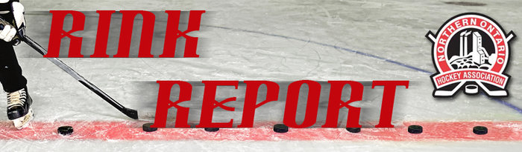
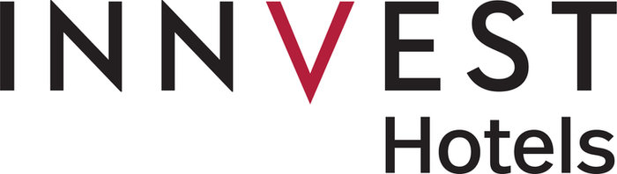
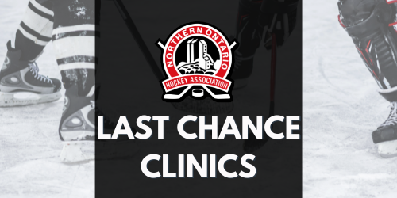
The NOHA has scheduled its absolute final clinic dates for the 2022-2023 season. Effective immediately, any individuals who are deficient are ineligible to participate until such time as they complete the appropriate certification requirement(s). If you require certification, please register for the appropriate course below or visit the Clinics Page.

Step 1: Determine which course you need to take in the NOHA Certification Requirements
Step 2: Click the link in the document or use the link below.
Step 3: Once you are registered, you will receive an email from Technical Director Jacob Brown (jbrown@noha-hockey.ca) the day before the clinic; this email includes everything you will need to attend.

Intro to Coach – December 12, 2022 – 6:00-10:00 PM

Coach level – December 13, 2022 – 6:00-10:00 PM

Questions may be directed to NOHA Technical Director Jacob Brown via email, jbrown@noha-hockey.ca .
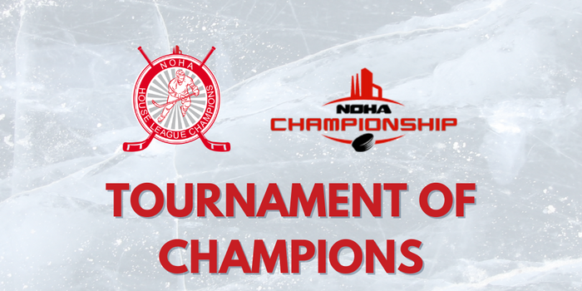
NOHA Tournament of Champions Team applications are open until December 19th at midnight!

Host Information
Online Team Application Form
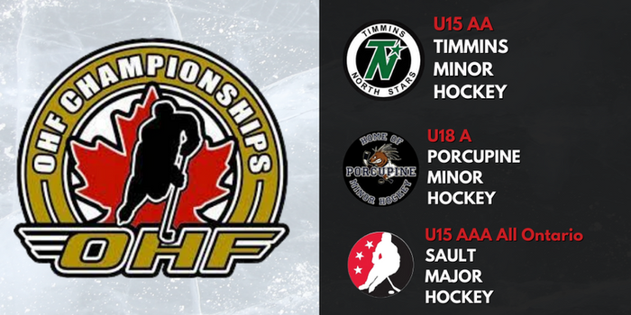
OHF Championships Hosts Announced
Read More

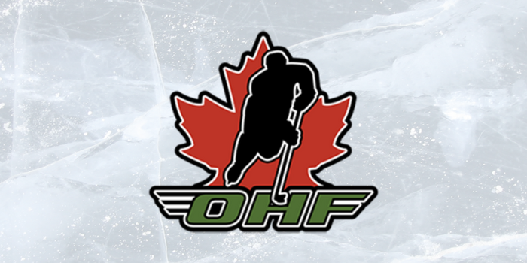
OHF Life Patron Award Nominations
Read More

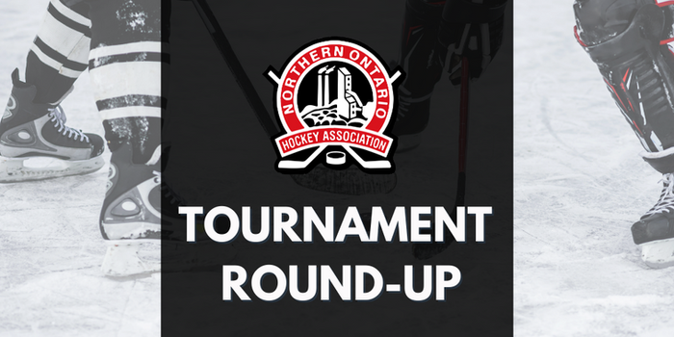
Has your team been a champion or finalist in a tournament? If so, we want to showcase it! Send your championship photos to Lindsay at lmorell@noha-hockey.ca before Tuesdays for your teams to be included in the Tournament Round-up!
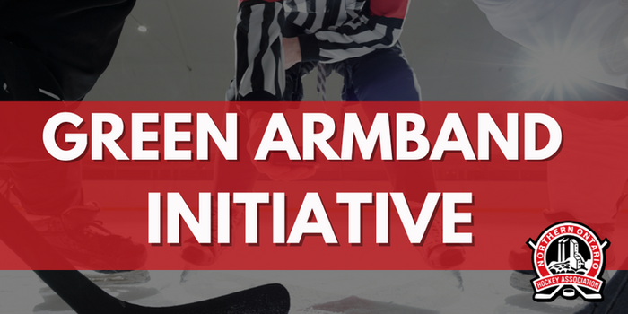
Clinics

Player Pathways

Resources

110 Lakeshore Drive, North Bay, ON, Canada
705 474-8851

NOHA Website

