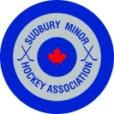
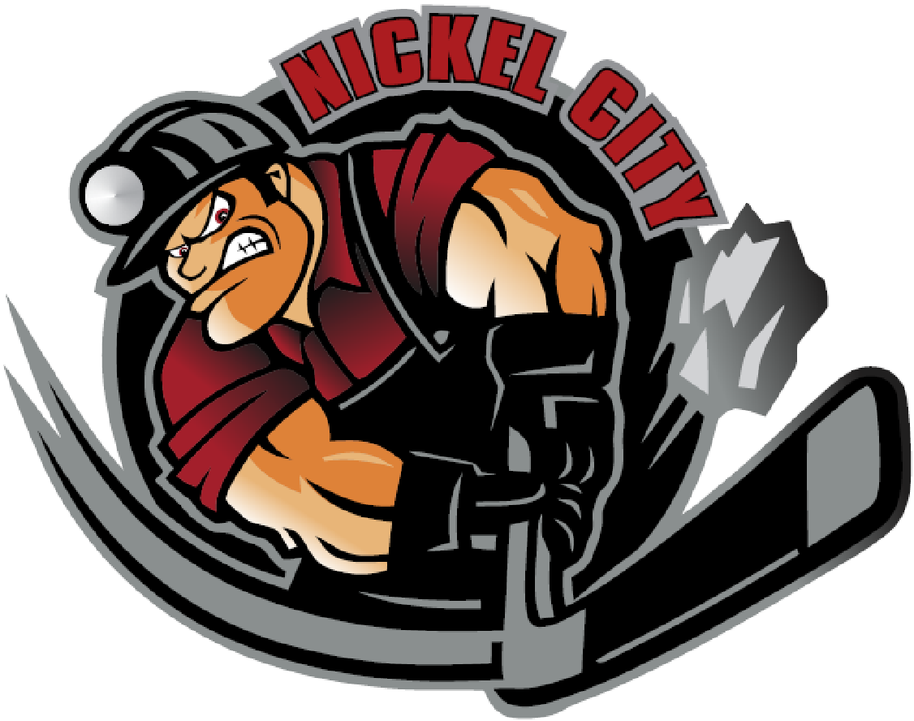

SMHA and NCHA are collaborating on AAA for the 2022-2023 Season!!

The NOHA has approved our plan to consolidate cards with each association hosting age groups as follows:

NCHA - U12AAA, U13AAA, U14AAA
SMHA - U15AAA, U16AAA, U18AAA

Leave of absences are as follows:

NCHA – U15AAA
SMHA – U12AAA, U13AAA, U14AAA

We will be posting coaching applications in the near future and will be collaborating on Coach selection, player evaluations and working together at all levels as needed throughout the season.

We are expecting an increase in the number of AA and/or A teams at the levels where we are dropping to a single AAA team.

Keep an eye on the NCHA and SMHA website for coaching applications!!

Sincerely,

Gaston Lescault & Angela Vendette
President President
NCHA SMHA

